Supporting the Transition to School Video Series – Social Media Content
To assist with promotion of the Supporting the Transition to School Video Series, Northern Sydney Local Health District (NSLHD) Population Health Promotion, School Years team have developed a range of social media content with suggested tiles and captions below.
For more information or questions please contact us at NSLHD-LiveLifeWellatSchool@health.nsw.gov.au or call (02) 9388 5390.

Tile/Graphic | Caption
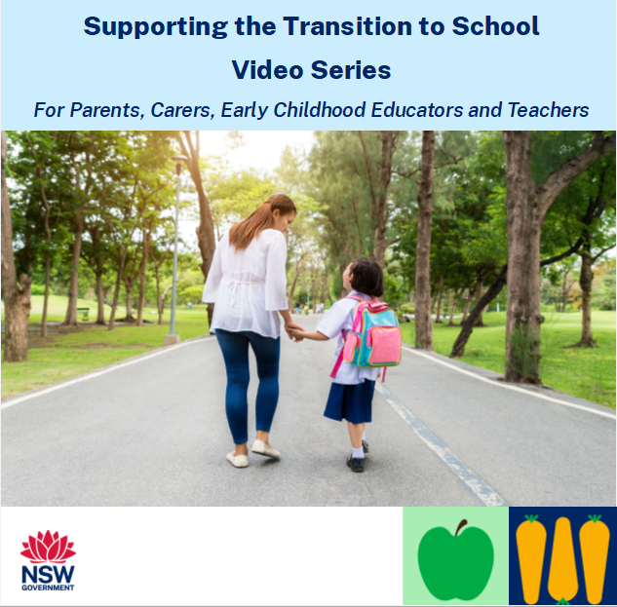 | Introducing the Supporting the Transition to School Video Series!  Getting ready for school involves more than just reading and writing skills. It includes developing skills such as:  - Movement skills (fine and gross motor skills)  - Self-management skills (emotional regulation)  - Interpersonal skills (communication skills)  These short videos have been developed by Northern Sydney Local Health District. They provide practical ideas to support development of these skills and assist a positive start to school.  Watch the video series that’s right for you:  - Teachers and Early Childhood Educators  - Parents and Carers  https://bit.ly/Transition2School  #TransitiontoSchoolVideoSeries
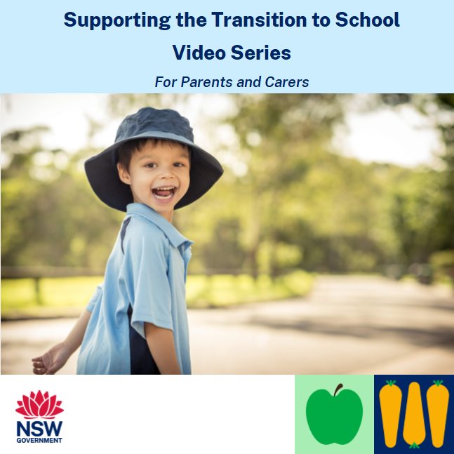 | Would you like support to help with your child’s transition to school?  Check out the Supporting the Transition to School Video Series created by Northern Sydney Local Health District.  Learn from Allied Health Professionals and Teachers on practical ideas to help parents and carers support a positive start to school.  Watch the video series for parents and carers here: https://bit.ly/Transition2School  #TransitiontoSchoolVideoSeries
Embed video ‘Supporting the transition to school’  https://vimeo.com/showcase/9854759/video/754565065 | Supporting the Transition to School Video Series | Watch now!  Is your child starting school in 2023? Watch the Supporting the Transition to School videos to learn practical ideas to support your child to have a smooth start to kindergarten.  Access the full video series for parents and carers here: https://bit.ly/Transition2School  #TransitiontoSchoolVideoSeries
Embed video ‘Fine and gross motor skills’  https://vimeo.com/showcase/9854759/video/754565155 | Supporting the Transition to School Video Series | Watch now!  Check out the second video in the series: Fine and Gross Motor Skills  Learn about the importance of movement skills for a child’s development!  Access the full video series for parents and carers here: https://bit.ly/Transition2School  #TransitiontoSchoolVideoSeries
Embed video ‘Developmental Milestones and Support’  https://vimeo.com/showcase/9854759/video/756604558 | Supporting the Transition to School Video Series | Watch now!  What are developmental milestones, and how to seek professional support for my child? Watch this video to learn more!  Access the full video series for parents and carers here: https://bit.ly/Transition2School  #TransitiontoSchoolVideoSeries
Embed video ‘Practising Gross Motor Skills at Home’  https://vimeo.com/showcase/9854763/video/754565369 | Supporting the Transition to School Video Series | Watch now!  Did you know it is important to develop your child’s gross motor skills in order to improve their writing skills? Developing gross motor skills can help your child to sit at a desk and control the movements in their shoulders, arms, wrists and fingers – important when starting school.  Looking for ways to support your child’s gross motor development? Watch this video to learn fun ideas to try with the family!  Access the full video series for parents and carers here: https://bit.ly/Transition2School  #TransitiontoSchoolVideoSeries
Embed video ‘Practising fine motor skills at home’  https://vimeo.com/showcase/9854763/video/756609314 | Supporting the Transition to School Video Series | Watch now!  Fine motor skills involve the small muscles in the hands, fingers, and wrists. These skills help with movements like drawing, writing and using scissors.  Watch this video to learn how to support your child’s fine motor skill development and assist their transition to school.  Access the full video series for parents and carers here: https://bit.ly/Transition2School  #TransitiontoSchoolVideoSeries
Embed video ‘Developing independence and self care skills’  https://vimeo.com/showcase/9854763/video/756983512 | Supporting the Transition to School Video Series | Watch now!  Being able to do tasks such as dressing, eating and going to the toilet independently makes it easier for children to take part in activities at school.  Help your child to develop their independence and self-care skills by watching this video.  Access the full video series for parents and carers here: https://bit.ly/Transition2School  #TransitiontoSchoolVideoSeries

