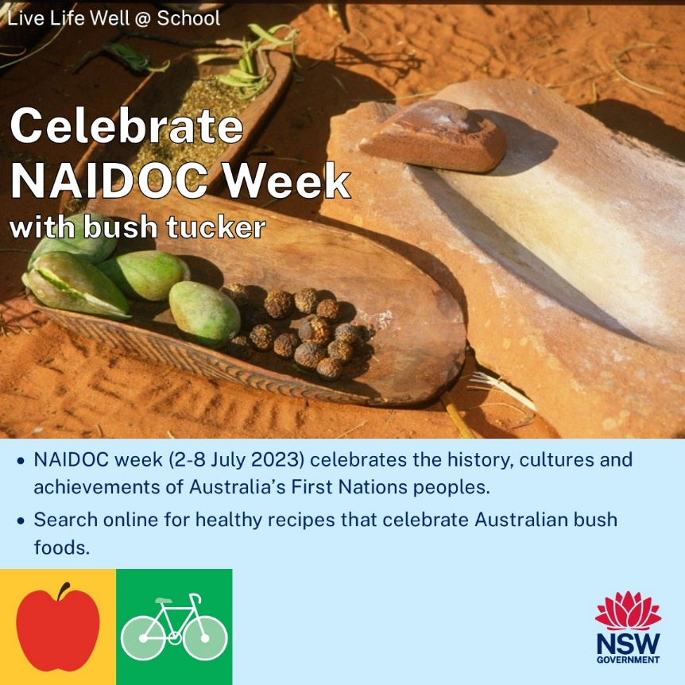



**TERM 2 2023**

**Newsletter Snippets Instructions**

Please see below a suite of newsletter snippets to incorporate into your communications with families.

The newsletter snippets are easy to copy and paste and provide information to families on:

|  |  |
| --- | --- |
| *Healthy Eating* | *Active Travel* |
| *Healthy Lunchbox* | *Physical Activity* |
| *Healthy Canteen* | *Limiting Screen Time* |
| *Crunch&Sip* | *Go4Fun* |

Click each image to access the hyperlinked website.

*Thanks! From the Northern Sydney LLW@S team* ☺

[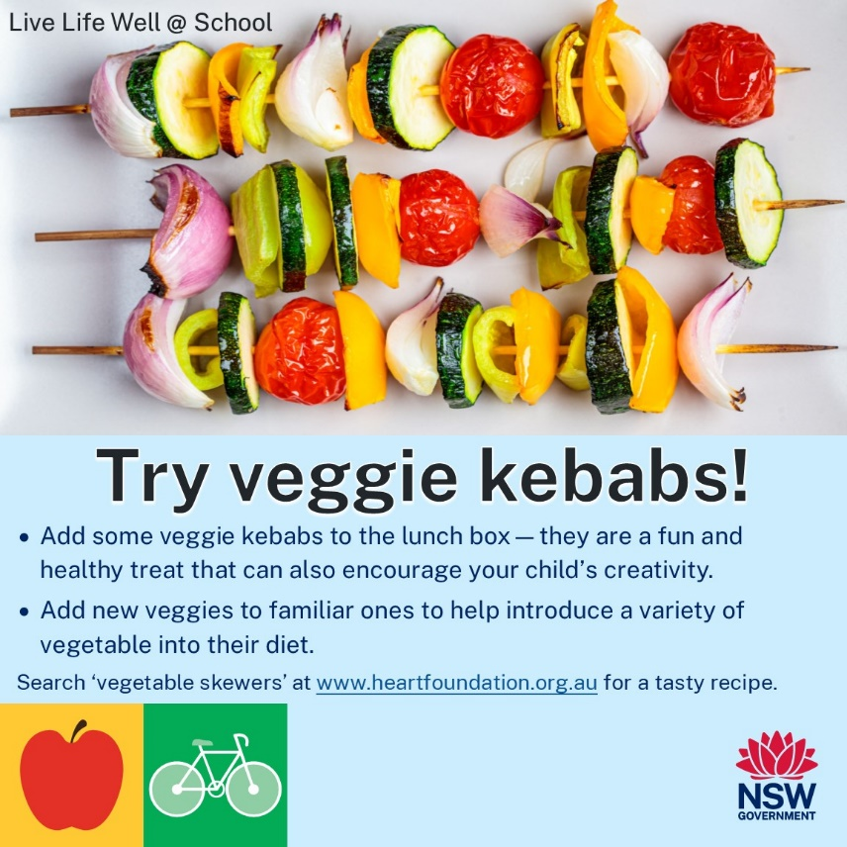](https://www.heartfoundation.org.au/recipes/honey-soy-vegetable-skewers)[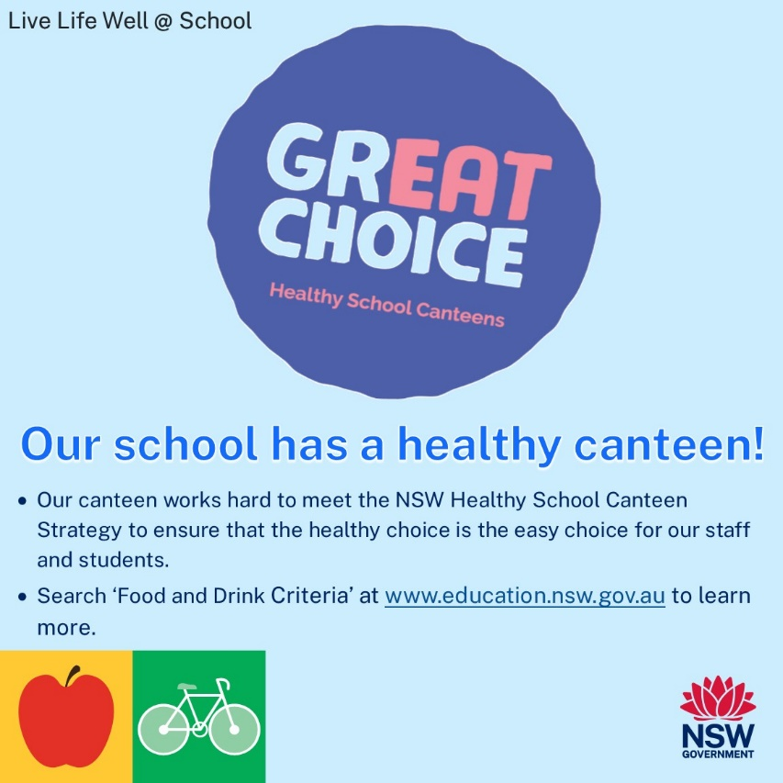](https://education.nsw.gov.au/student-wellbeing/whole-school-approach/healthy-canteens/food-and-drink-criteria)

[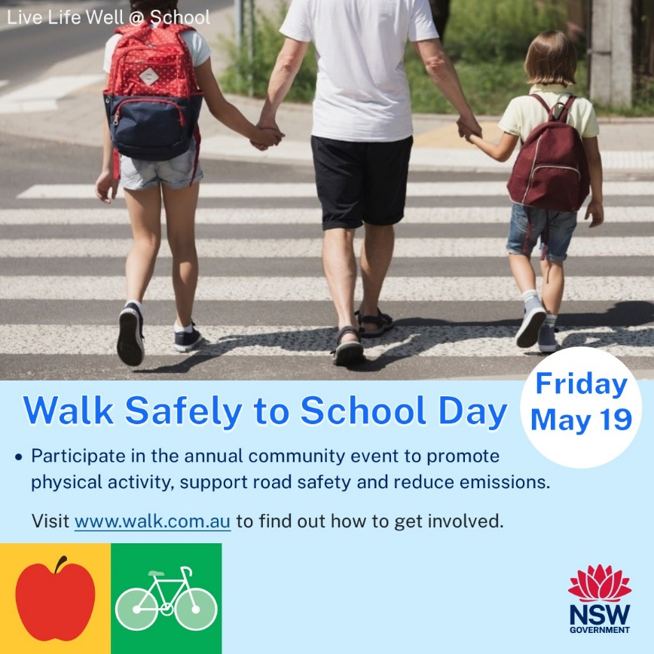](https://www.walk.com.au/WSTSD/how-to-participate.asp)[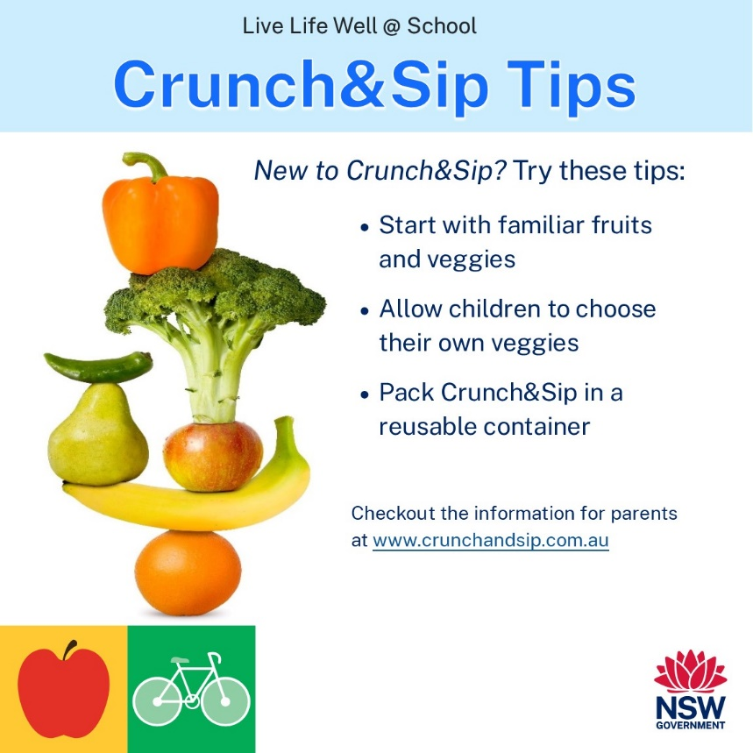](https://www.crunchandsip.com.au/parents/why-participate)[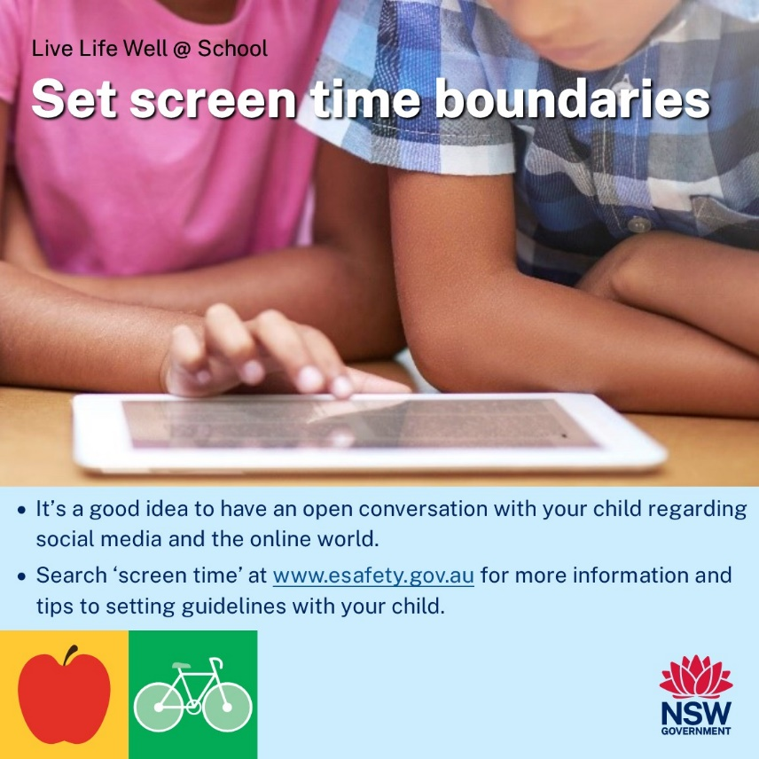](https://www.esafety.gov.au/parents/issues-and-advice/screen-time)

[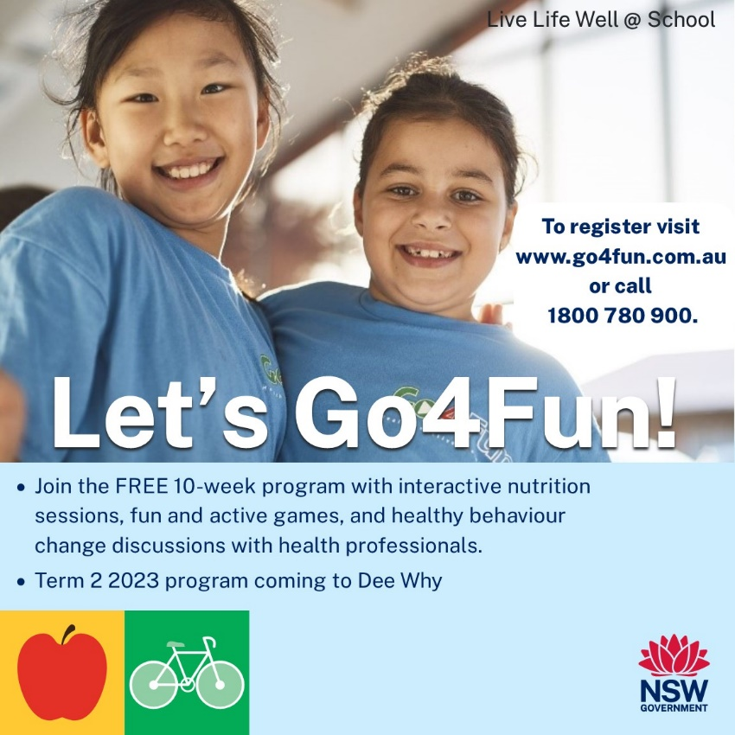](https://go4fun.com.au/register/)

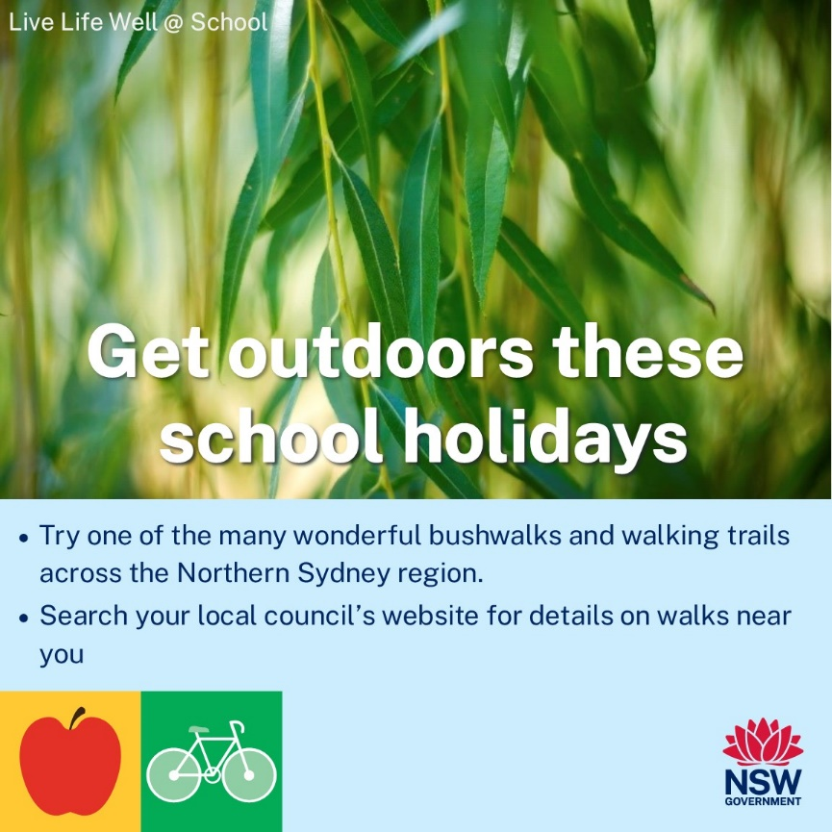[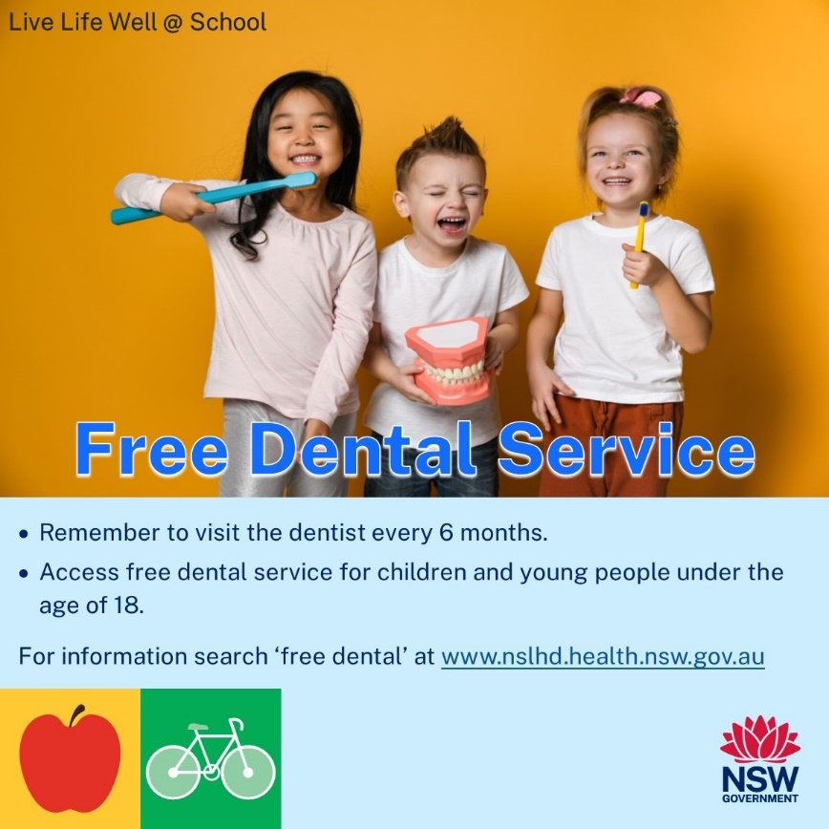](https://www.nslhd.health.nsw.gov.au/Services/Pages/Oral_Health.aspx)

[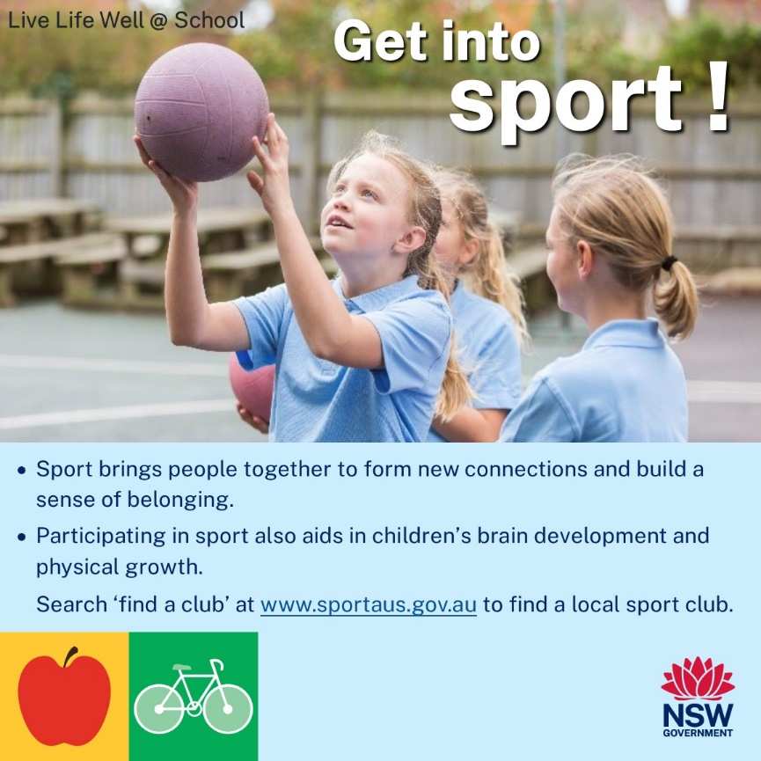](https://www.sportaus.gov.au/schools/find-a-club#!)