[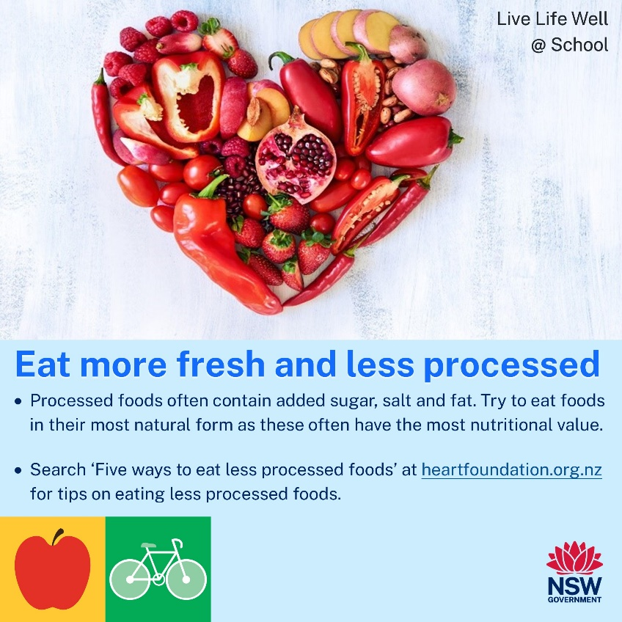](https://www.heartfoundation.org.nz/about-us/news/blogs/five-ways-to-eat-less-processed-food)



**TERM 3 2023**

**Newsletter Snippets Instructions**

Please see below a suite of newsletter snippets to incorporate into your communications with families.

The newsletter snippets are easy to copy and paste and provide information to families on:

|  |  |
| --- | --- |
| *Healthy Eating* | *Active Travel* |
| *Healthy Lunchbox* | *Physical Activity* |
| *Healthy Canteen* | *Limiting Screen Time* |
| *Crunch&Sip* | *Go4Fun* |

*Thanks! From the Northern Sydney LLW@S team* ☺

[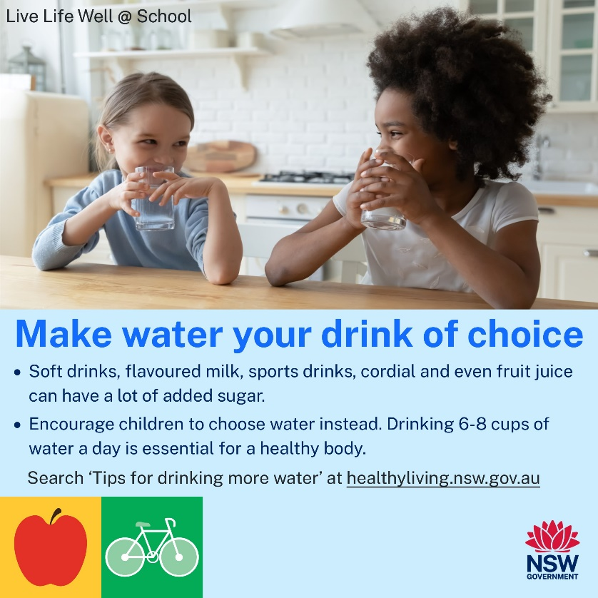](https://www.healthyliving.nsw.gov.au/food/tips-for-drinking-more-water)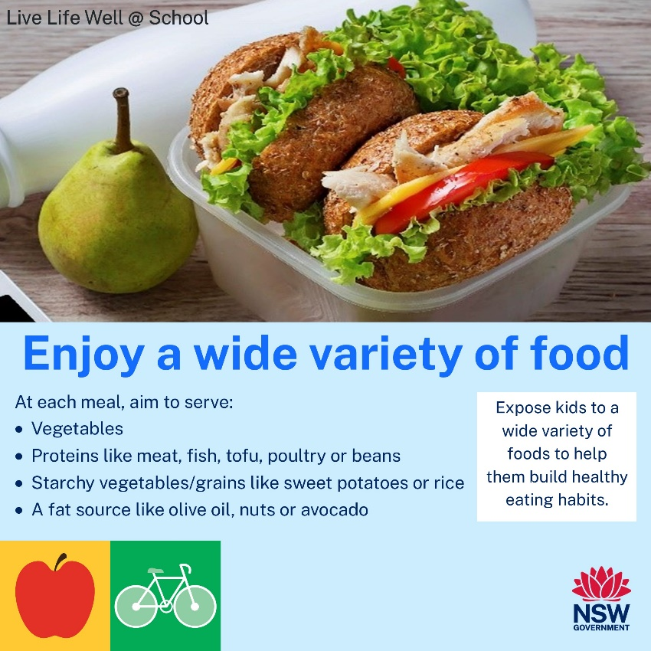

[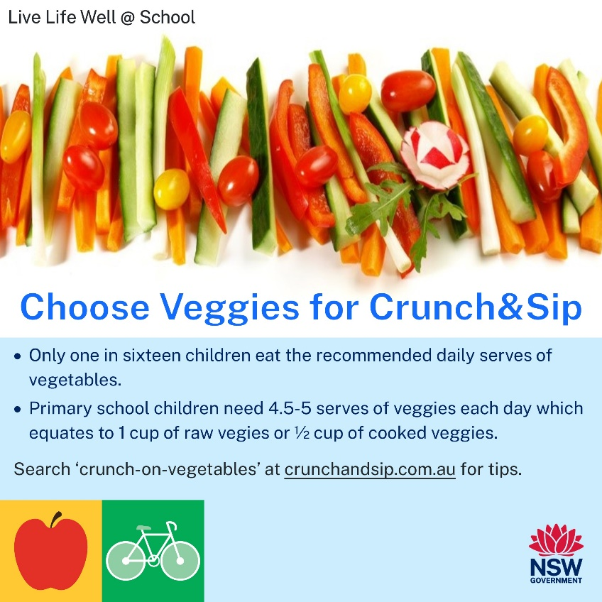](https://www.crunchandsip.com.au/parents/healthy-tips)[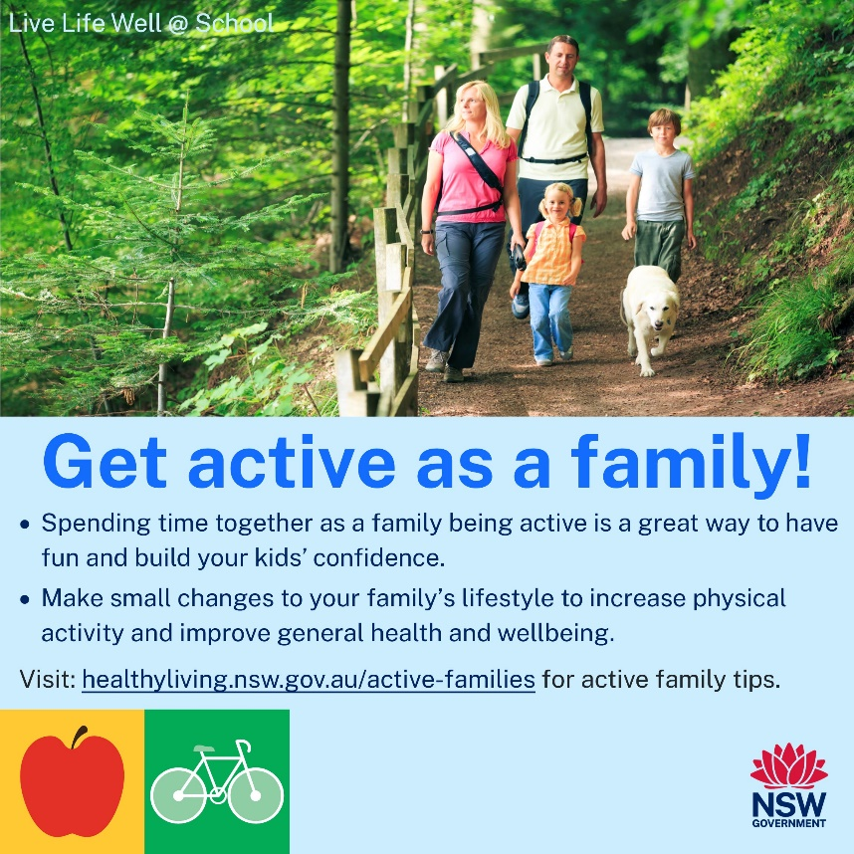](https://www.healthyliving.nsw.gov.au/Pages/stay-active-families.aspx)

[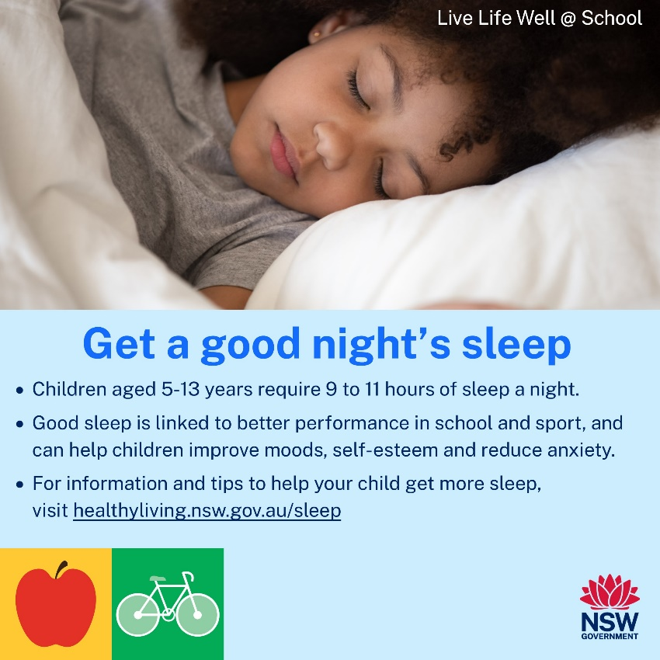](https://www.healthyliving.nsw.gov.au/sleep)[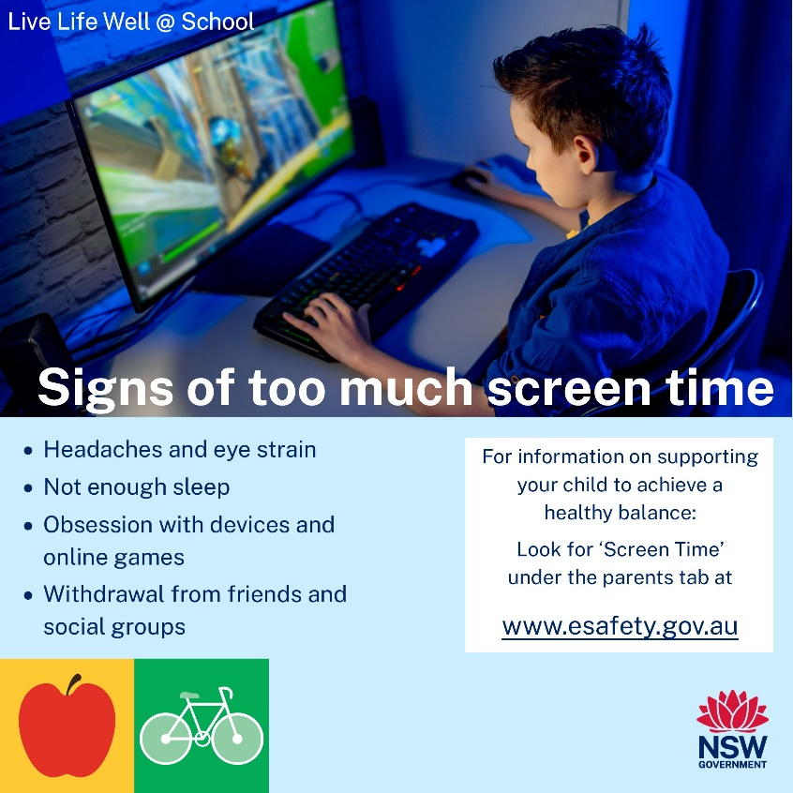](https://www.esafety.gov.au/parents/issues-and-advice/screen-time)

[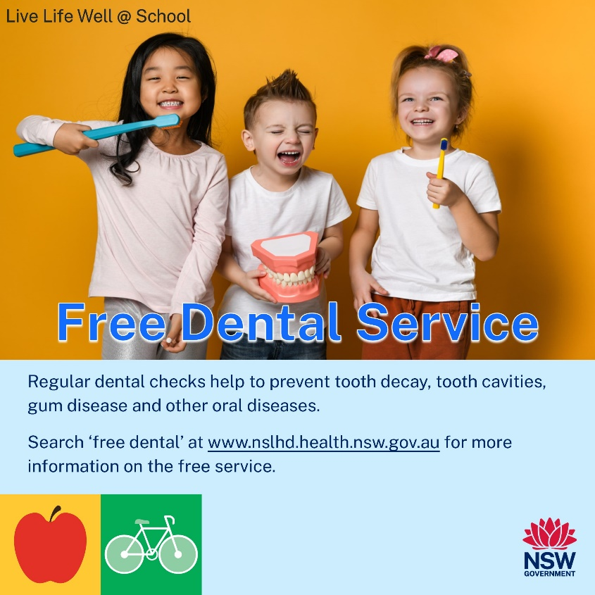](https://www.nslhd.health.nsw.gov.au/CYFH/services/Pages/OralHealth.aspx)[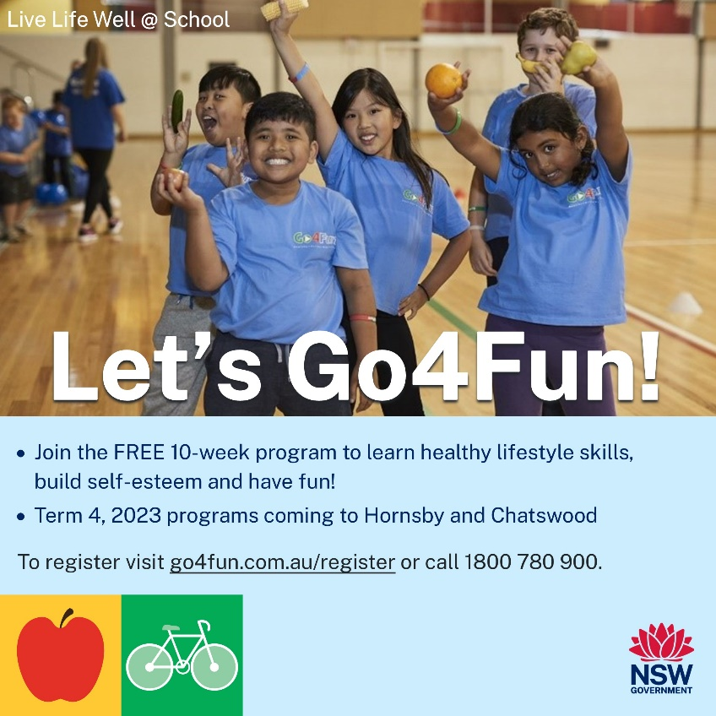](https://go4fun.com.au/register/)