[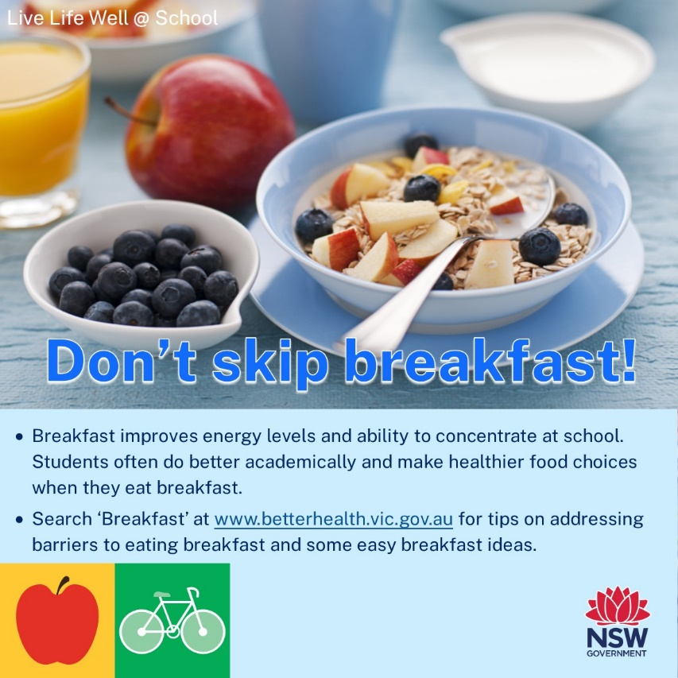](https://www.betterhealth.vic.gov.au/health/healthyliving/breakfast)



**TERM 1 2023**

**Newsletter Snippets Instructions**

Please see below a suite of newsletter snippets to incorporate into your communications with families.

The newsletter snippets are easy to copy and paste and provide information to families on:

|  |  |
| --- | --- |
| *Healthy Eating* | *Active Travel* |
| *Healthy Lunchbox* | *Physical Activity* |
| *Healthy Canteen* | *Limiting Screen Time* |
| *Crunch&Sip* | *Events/Go4Fun* |

*Thanks! From the Northern Sydney LLW@S team* ☺

[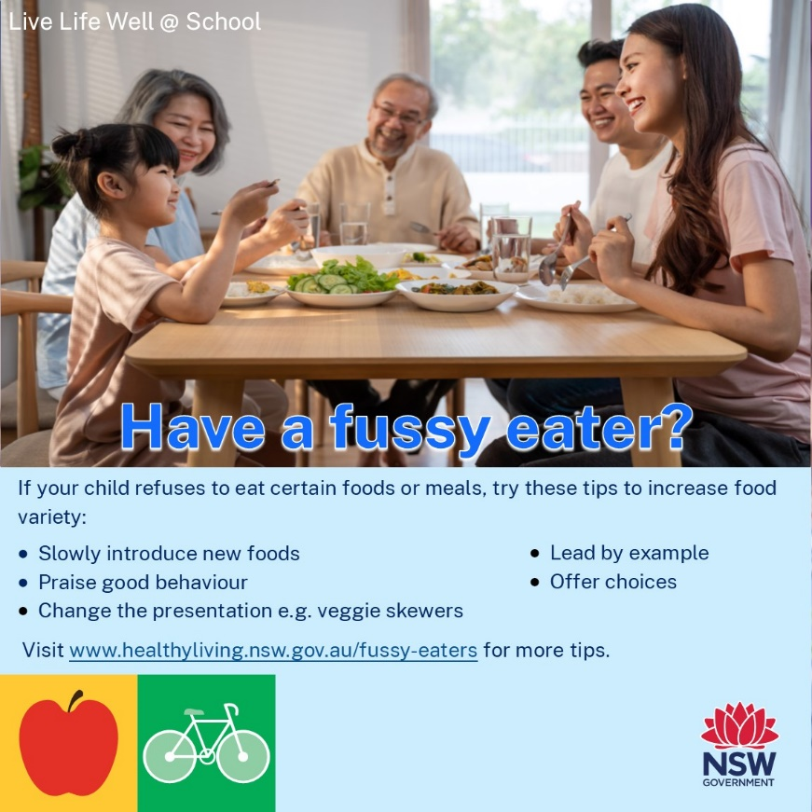](https://www.healthyliving.nsw.gov.au/fussy-eaters)[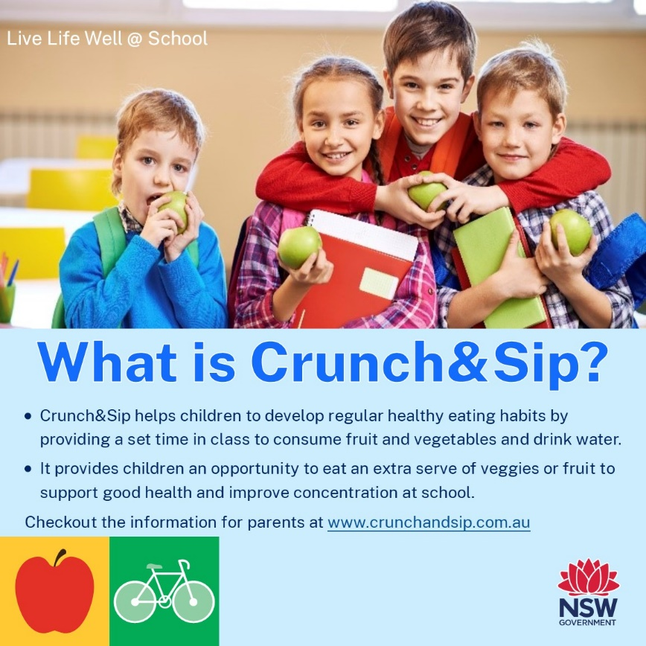](https://www.crunchandsip.com.au/parents/why-participate)

[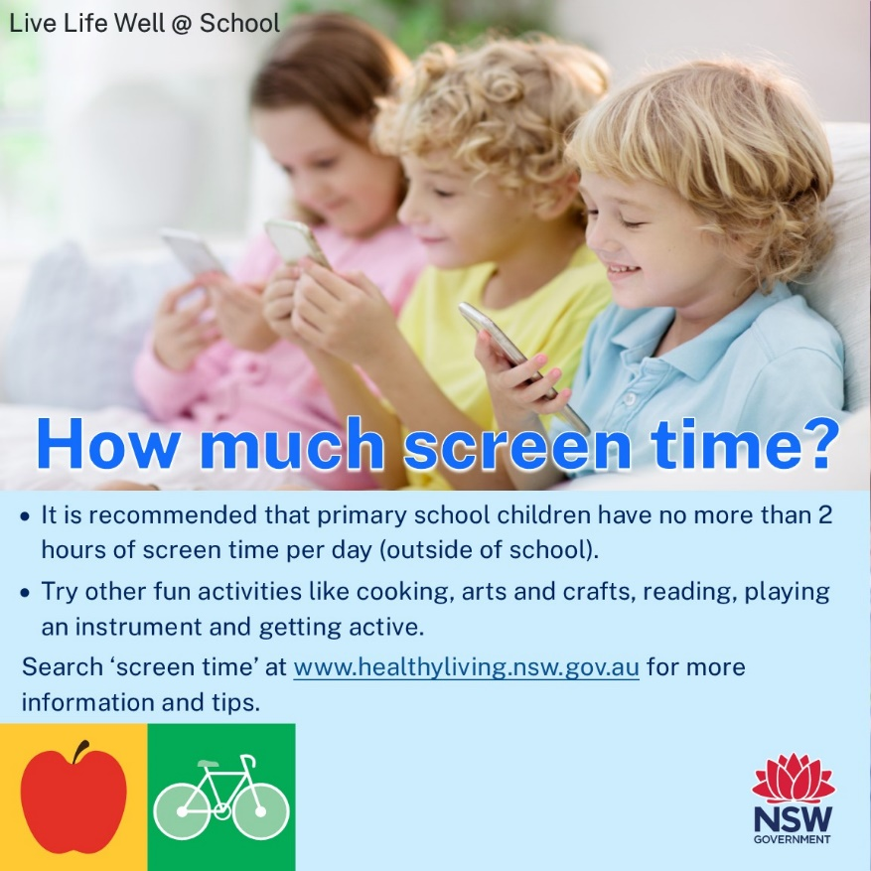](https://www.healthyliving.nsw.gov.au/Pages/screen-time.aspx)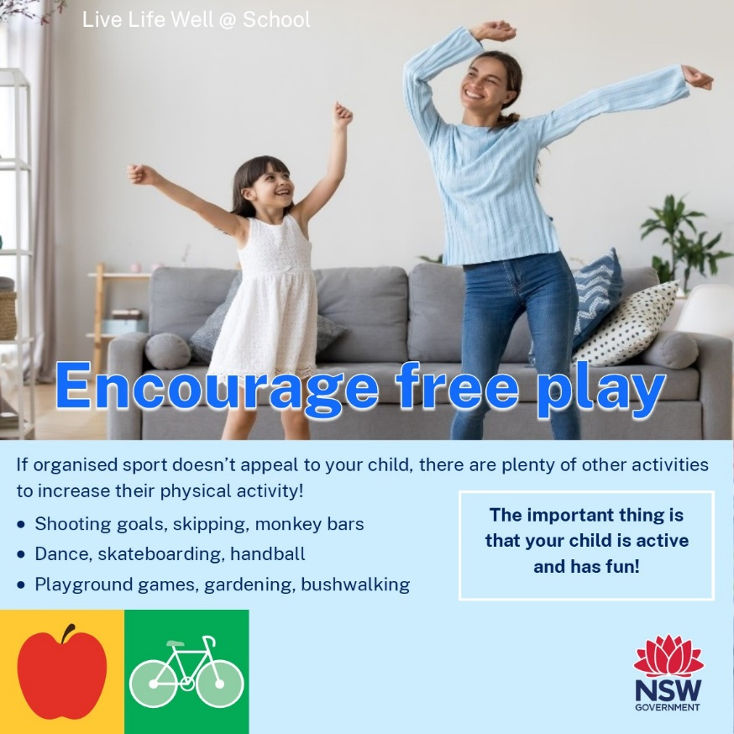

[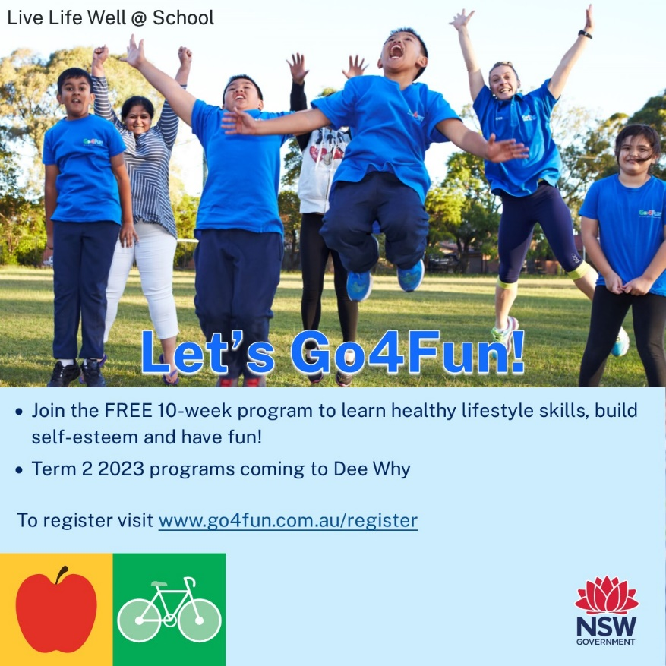](https://go4fun.com.au/register/)[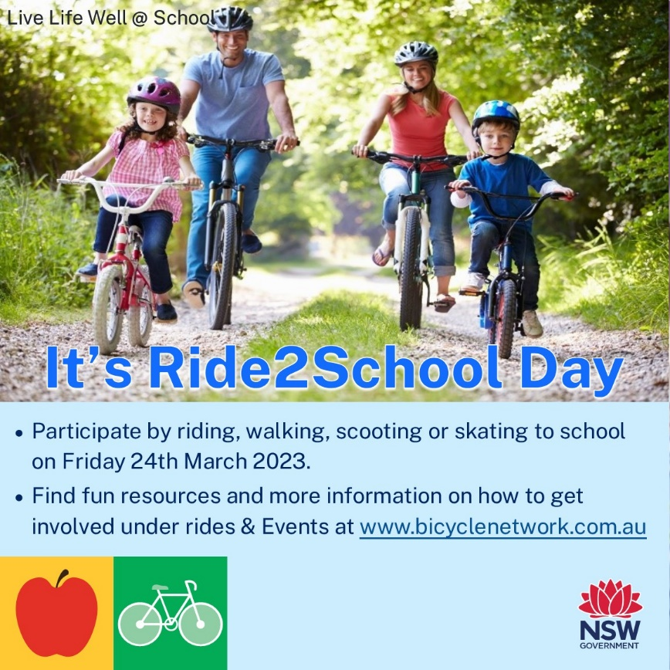](https://www.bicyclenetwork.com.au/rides-and-events/ride2school/ride2school-day/)

